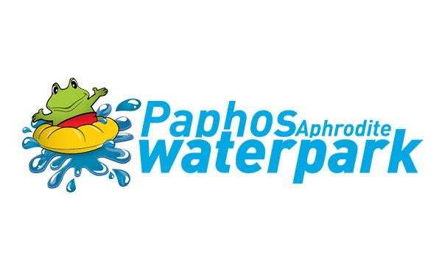

A&A SUPER APHRODITE PARK LTD - Poseidonos Avenue
P.O Box 61357, 8133 - Paphos , Cyprus
Tel: 26 913 638 Website: www.aphroditewaterpark.com
VIP MEMBERS CARD
Personal information
Card Holders full name

TELEPHONE /EMAIL

Date of birth
Signature
Name of spouse/partner

Date of birth

Signature
Name of 1st child

Date of birth

Signature
Name of2st child

Date of birth

Signature
Name of 3st child

Date of birth
Signature
Name of 4st child

Date of birth

Signature

Terms and Conditions
It is illegal to copy, loan, rent or sell the card anyway.
The company reserves the right to withdraw the card in any case of misuse.
In case the authorised holder loses the card, he/she must notify the company immediately.

By signing this document you provide A&A Super Aphrodite Park Ltd with the permission to retain your data for the duration of this season (until 31 October). All personal data will be stored securely. All personal data will be retained for 1 year (for one season) and will then be securely erased or shredded. No unnecessary data will be collected and no data will be passed on to a third person, other than required by the laws of Cyprus.

Signature ............................... Date .................................

